Oracle is a ORDBMS product / DB software / backend tool from “oracle corporation” introduced .

Larry Ellison and team started consultancy software development in 1977 , which became RSI in 1983 and later to Oracle Corporation

In 1979 RSI introduced Oracle V2 ( version 2 ) as the first commercially available SQL – based RDBMS

It is one of the most popular ORDBMS in IT market for storing , organizing and retrieving data.

It can be deployed in almost all leading operating systems such as Linux , windows , Mac , Solaris IBM Aix , etc..

Editions of Oracle :

* **Enterprise Edition:**  It offers all features, including superior performance and security.
* **Standard Edition:** It provides the base functionality for users that do not require Enterprise Edition's all features .
* **Express Edition (XE):** It is the lightweight, free and limited Windows, and Linux edition.
* **Oracle Lite:** It is designed for mobile devices.
* **Personal Edition:** It's comparable to the Enterprise Edition but without the Oracle Real Application Clusters feature.

Oracle Client Server Architecture :

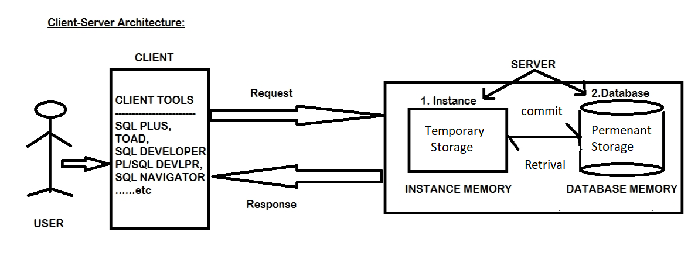

Here user uses some client tools Eg: SQL plus , Toad , SQL Developer , PL/Sql Developer , Sql , Navigator to connect , request any data and get the response from the server. And to communicate with the database a language is needed i.e sql ( structured query language )

1. In the first step connect to the server with the login credentials .
2. Write any sample query and execute that . it will be stored temporarily in the instance memory . now if user disconnects , then the data will be lost. Then the user has to login again and do the operations again.
3. To avoid data loss , the data should be moved from instance to database using the command “commit” . once the data is moved to database , it is stored permenantly unless it is removed / deleted by the user.
4. The stored data can be retrieved whenever the user needed.

Is SQL Plus and SQL same ?

SQL Plus is a client tool introduced by Oracle, that is used to connect to the sever ( database ) ,request any data and get response.

While SQL is a language used to communicate with the database .

So for connecting with Oracle database SQL Plus is used and to communicate with that database SQL is used.

Note : in oracle username is not case-sensitive but password is case sensitive

Connecting with the database

1. Open SQL plus and give the username and password . by default the password is not visible to user .
2. If you want to see the password while connecting use “ conn ” command and execute/ press enter

* Syntax : username/password

Problem -1 : During the login sometimes “ORA – 12560 : TNS : protocol adapter error” may arise , to solve this

* Go to services
* Navigate to oracleserviceORCL
* Select the startup and make it “automatic”
* Click on start and ok.

Problem -2 : ORA-28000 : this account is locked.

If this error arises login as system dba administrator

To login as system dba administrator use command

* “\sys as sysdba” in the user name and give the password .
* To lock / unlock a user in the oracle database server

Syntax : ALTER USER <username> ACCOUNT LOCK/UNLOCK;

Note : generally installing oracle DB and creating user is done by DBA Administrators in IT sector . just login credentials are given to the DBdeveloper .

To create a new user and password in oracle DB

Syntax :

CREATE USER <username> IDENTIFIED BY <password> ;

If user tries to login to that account this error may occur

ORA-01045 : user username lacks CREATE SESSION privilege ; login denied

Here account is created but he doesn’t have permissions to connect. Every new user ill not have any privileges ( permissions ) to perform operations like connect , create table , insert data etc… admin should give the permission using the command “grant” .

Every new user is called as “schema” in Oracle. Where schema is a collection of objects such as “ tables , views , synonyms , procedure , triggers etc…”.

Syntax for granting permission to the new user :

Login as admin

And use command : grant < privilege_name > to < user_name>

Eg: grant connect to username

To change password for the account

Syntax: PASSWORD

Old password :

New password :

Provide old and new password.

To create a new password for forgotten password use command

Login as admin and use command

Syntax : ALTER USER <username> IDENTIFIED BY <new_password>

How to check/view the usernames

Syntax : before viewing the usernames use 2 commands

“SET PAGESIZE 100” the number can be of user choice

“SET LINES 160 “ the number can be of user choice

/* command to view usernames */

SELECT * FROM ALL_USERS ;

To exit from sql plus use command “EXIT”

Or

“QUIT”